**SEARCH RESULTS FOR MAIZE (CORN) FOR NORTHERN REGION, GHANA; OMNI-AI**

**1) Average weather pattern for Northern Region, GHANA**

* **Hottest Month**: March (33 °C avg)
* **Coldest Month:** August (27 °C avg)
* **Wettest Month**: August (239.7 mm avg)
* **Windiest Month:** April (9 km/h avg)
* **Annual Rainfall:** 1165.3 mm (per year)

**2) Rainfall pattern for Northern Region, GHANA**

|  |  |  |  |  |  |  |  |  |  |  |  |  |  |
| --- | --- | --- | --- | --- | --- | --- | --- | --- | --- | --- | --- | --- | --- |
| **Tamalé - Average precipitation** | | | | | | | | | | | | | |
| **Month** | **Jan** | **Feb** | **Mar** | **Apr** | **May** | **Jun** | **Jul** | **Aug** | **Sep** | **Oct** | **Nov** | **Dec** | **Year** |
| Prec.(mm) | 2 | 9 | 50 | 90 | 120 | 130 | 130 | 190 | 215 | 100 | 13 | 5 | **1054** |
| Prec.(in) | 0.1 | 0.4 | 2 | 3.5 | 4.7 | 5.1 | 5.1 | 7.5 | 8.5 | 3.9 | 0.5 | 0.2 | **41.5** |
| Days | 0 | 1 | 3 | 6 | 8 | 10 | 10 | 12 | 16 | 9 | 1 | 1 | **77** |

* Squalls occur in the northern part of Ghana during March and April,
* Followed by occasional rain until August and September, when the rainfall reaches its peak.

**3) Average amount of rainfall in mm for Northern Region, GHANA**

* 78 to **216 centimeters** (**31 to 85 inches**) a year

4) Average regional climate for Northern Region, GHANA

The climate of the region is relatively dry, with a single rainy season that begins in May and ends in October. The amount of rainfall recorded annually varies between 750 mm and 1050 mm. The dry season starts in November and ends in March/April with maximum temperatures occurring towards the end of the dry season (March-April) and minimum temperatures in

The main vegetation is classified as vast areas of grassland, interspersed with the guinea savannah woodland, characterized by drought-resistant trees such as the acacia, baobab, shea nut, dawadawa, mango, neem

**5) Specific natural disasters that affect Northern Region, GHANA**

* Floods
* Drought
* Bush fires

**6) Frequency of the above Natural disasters in Northern Region, GHANA**

* Droughts occur in September and October when they do
* Floods occurred July and in November
* Bush fires in November and December when drought occurs

**7) General soil type in Northern Region, GHANA**

Predominantly light textured surface horizons in which sandy loams and loams.

**8) Best propagation or farming methods for maize in Northern Region, GHANA**

**Hand planting**

A measuring tape is used to mark 25cm/40cm depending on maize variety along a measuring line for the distances between the seeds. A second measuring line is measured at a distance of 75cm/80cm/90cm between rows depending on maize variety.

A planting stick is used to make two holes at the same time, one at a depth of 5cm for seed and the other at a depth of 10cm for an application of 10g of fertilizer.

Place the seed and make the final covering. Make sure that the seed is well holed in to ensure good contact with moisture. All seeds must be well covered.

**Mechanical planting**

This type of planting has the advantage of being quick, and if well supervised will give excellent results. However, if it is poorly supervised, it will give poor-to-disastrous results. It allows you to plant a large acreage within your pre-determined planting period. Adapt a spacing compatible with other mechanical operations like fertilizer application and weeding. Check the machine well before the anticipated planting date to make proper adjustment. Always read the operator's manual and seek advice from the suppliers for effective usage. Every season, make sure that the planter is calibrated to avoid making costly mistakes.

* Below are some guidelines for calibration:
* Each planter must be tested separately.
* Select plates that will allow the largest seed of your seed sample to go through. Make sure the plate does not allow two seeds at a time.
* Make sure that the driving wheel drops seeds in the furrow opener.
* Count the number of seeds dropped by the planter over a measured length in the field at a set driving speed. The number can be multiplied to get total number dropped / ha. The correct operating speed is normally indicated in the operator's manual e.g. 5 km/h.

**9) Historical planting time for maize in Northern Region, GHANA.**

* **Major Season:** May through the third week of May
* **Minor Season:** The third week of August to end of September.

**10) Best planting time for maize in Northern Region, GHANA.**

* July through early August

**11) Historical Harvesting time for maize in Northern Region, GHANA.**

August

**12) Best Harvesting time for maize in Northern Region, GHANA.**

September

**13) Top two natural fertilizer options for maize in Northern Region, GHANA.**

* Cow dung
* Chicken manure

**14) Top two chemical fertilizer options for maize in Northern Region, GHANA.**

In general, rates of applications per hectare in Ghana average around 90 kg N. 60 kg P2O5 and 60 kg K2O. However, fertilizer N levels up to 120 kg/ha are recommended for cultivation in degraded soils.

**15) Common Maize crop disease to expect during the farming season in Northern Region, GHANA.**

* Maize Streak
* Northern leaf blight

**16)** **Top three Maize crop diseases to expect during the farming season in Northern Region, GHANA**

* Maize Streak
* Northern leaf blight

**17) Common Maize crop pests to expect during the farming season in Northern Region, GHANA**

* Fall Armyworms
* Lesser Grain Weevils (storage pest)

**18) Top three** **Maize crop pests to expect during the farming season in Northern Region, GHANA**

* Fall Armyworms
* Termites
* Lesser Grain Weevils (storage pest)

**19) Best soil type for maize in Northern Region, GHANA**

Well-drained, well-aerated, deep warm loams and silt loams containing adequate organic matter and well supplied with available nutrients.

**20) Agric policy in direct relation to Maize in Northern region Ghana.**

Government intends to construct a 1, 000 metric tonne capacity warehouse in each district to provide handling and storage space for the surpluses which are anticipated. In order for the surpluses not to stay in the warehouses for long and to encourage the consumption of local food, the Ministry of Food and Agriculture will enter into agreements with the Ministries of Gender, Education and Health to purchase foodstuffs for the School Feeding Programme, for colleges, hospitals and other state institutions.

**21) Type of government subsidy for maize in Northern region Ghana.**

For the compound fertilizer of 50kg/ha, out of the full cost of Gh¢115.00 government subsidy amounts to Gh¢26.00 thus pegging the selling price at Gh¢89.00, representing 26% in price reduction while for Urea, government subsidy on 50kg/ha costing Gh¢105.00 was Gh¢21.00, representing a 20% of subsidy.

The market prices for both the compound fertilizer and the urea were Gh¢89.00 per 50kg bag and Gh¢84.00 per 50 kg bag, respectively. By these price reductions, it is estimated that government is subsidizing fertilizer at an average of 21%.

**22) Lowest Market price over the past three years for Maize in Northern region Ghana.**

GHS 96 for a Bag of maize

**23) Highest Market price over the past three years for Maize in Northern region Ghana.**

GHS 115 for a Bag of maize

**24) Best Market price over the past two years for Maize in** **Northern region Ghana.**

GHS 175 for a Bag of maize

**25) Historically best month to sell harvested maize in** **Northern region Ghana.**

* May
* August

**26) Top two areas of demand for maize from** **Northern region Ghana.**

* Accra
* Kumasi
* Takoradi

**27)** **Top countries of demand for** **maize from** **Northern region Ghana.**

* Ivory Coast
* Burkina Faso
* Mali

**28) Best storage option for harvested Maize grains in** **Northern region Ghana.**

Government Regional warehouses

**29) General life cycle of Maize in Northern region Ghana.**

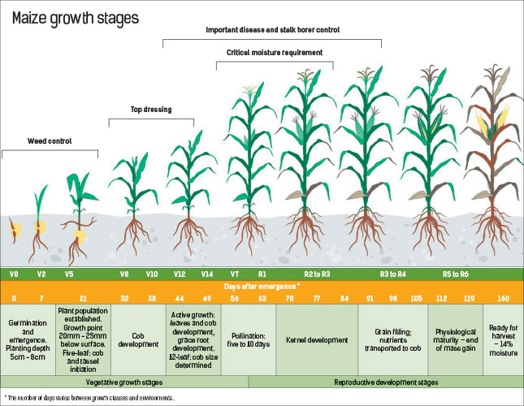

**30) Top three varieties of Maize in Northern region Ghana.**

* Obaatanpa
* Mamaba
* Dupont Pioneer Hybrid